

SUPERIOR UNIVERSITY LAHORE
GOLD CAMPUS

NAME: MUHAMMAD MOIZ RAZA
ROLL NO: SU92-BSAIM-F24-061
PROGRAM: ARTIFICIAL INTELLIGENCE
SEMESTER: 3rd SEMESTER
SECTION: BSAI-3A
SUBJECT: ARTIFICIAL INTELLIGENCE

Submission Title: LAB TASK-8
- Write code for Min Max Algorithm
Submitted To: Sir RASHIK ALI

LAB TASK-8
TASK: Write code for Min Max Algorithm
Why we write this code?

We write this code to help the computer make smart choices in a game where two players are playing against each other. The idea of this program is called Minimax, and it is used in many games like chess, tic-tac-toe, or checkers. One player tries to get the highest score (the maximizer), and the other tries to stop them or get the lowest score (the minimizer). This code helps the computer think ahead and decide what move is best to win or not lose.

How the Code Works
The code checks all the possible moves that can happen in the game. It uses something called recursion, which means the function keeps calling itself again and again to see what will happen next. If it’s the max player’s turn, the code chooses the biggest value because that player wants the highest score. If it’s the min player’s turn, it chooses the smallest value because that player wants to block the other one. It keeps doing this until there are no more moves left, then it goes back up and decides which move gives the best result.
What it does in the end
In the end, the program finds the best score or the best move the first player can make. It shows what the player should do to win or get the best result, assuming both players are playing in the smartest way possible.

OUTPUTS:
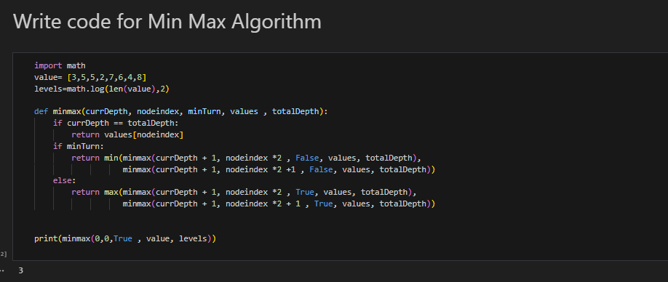

THE END

